Epigenetics
- Gene expressions: The process of copying information from DNA onto mRNA and translating the message into a series of amino acids.
- Protein synthesis: The process that the genetic code within the nucleus is used to produce structural or metabolic proteins (not genetic).
- Epigenetics: The non-genetic processes (environmental factors) that change the gene expression of the genetic code.
- DNA is coiled around histones.
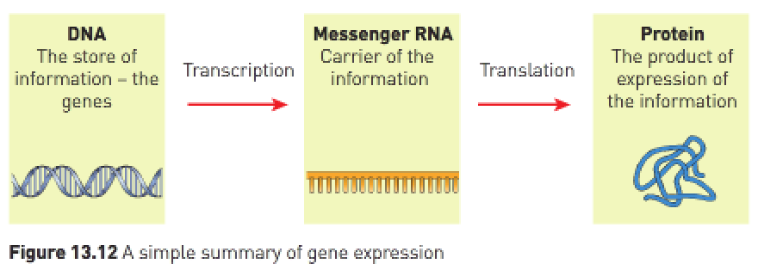
- Genes that are being used to make mRNA are said to be “switched on”.
- Genes not being used to make mRNA are said to be “switched off”.
- If the DNA is coiled tightly (called DNA methylation) the RNA polymerase can’t form mRNA and therefore the process of protein synthesis can’t occur.
- Methyl molecules bind to DNA and block access to genes. Tightly coiled DNA is inaccessible to RNA polymerase.
- If the histones move further away from each other (called DNA acetylation) the RNA polymerase can build mRNA and protein synthesis can occur.
- Acetyl molecules bind to histones and improve access to genes.
- Environmental (epigenetic) factors e.g., diet exercise, etc. influence DNA methylation and/or histone acetylation and therefore acts to switch genes on or off.

- Methyl and acetyl control gene expression by controlling access to DNA.
- RNA polymerase in the cell is blocked by methyl that binds directly to DNA or when DNA is wound tightly around histones.
- Access is easier when acetyl causes DNA to be wound more loosely around histones.
- Enzymes play an important role in gene expression by facilitating the addition and removal of methyl and acetyl.

